***Deposit Adjustment***

***Tables Involved****: Transaction Type, Transactions, Deposit*

***Purpose****: To match actual quantities of materials in the Warehouse to the availability reflected the database.*

*Often system reflects quantities of materials that no longer can be use because of expiration date, damage or loss. In this case, to align quantities to actually available in the warehouse regular inventory checks are performed. In case when quantities on hand are* ***lower*** *than indicated in the system user should perform Adjustment and specify the reason.*

*To perform adjustment:*

*User navigates to* ***Warehouse🡪 Deposits🡪 Manage Deposits tab*** *and selects deposit.*

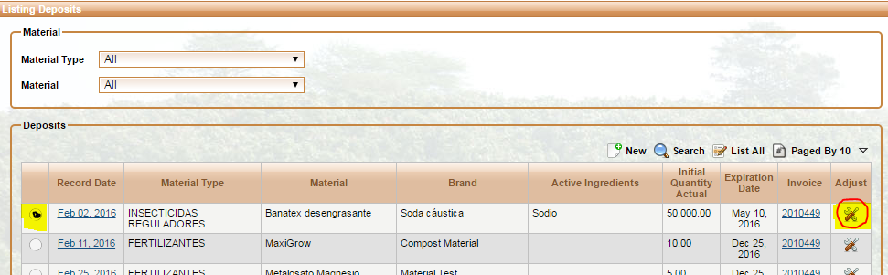

*When User clicks on the “Adjust” icon new pop –up window opens:*

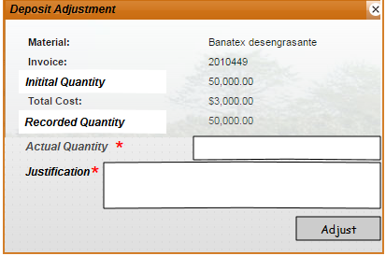

*1. Material – value comes from Deposit table and reflects material corresponding to Material_Id .*

*2. Invoice Number – invoice matching corresponding Invoice_ID - read only*

*3. Initial Quantity = Deposit . initial_quantity_actual – read only*

*4.* Recorded Quantity =Deposit.*real_quantity_actual – read only*

*5. Actual Quantity : User enters actual quantity - quantity that was found in the warehouse - editable and required field (real).*

***!*** *Quantity entered should be less than* ***Deposit. real_quantity_actual*** *for selected Deposit_ID.*

*This is the only transaction that is not associated with any Activity.*

*6. Justification - editable and required field (text).*

*7. Once user clicks on the “Adjust”. Warning with request of confirmation*

*appears: “Reduce existing quantities? OK /CANCEL”*

*8. If user decided to reduce quantities, system:*

1. *Creates new record in Transaction Table with Transaction Type = Adjustment*
2. *Populate “date_time” as system time*
3. *Calculate quantity*  as ***Deposit.real_quantity_actual*** **– Actual Quantity** ( as entered by user). *This value should be less than Deposit.real_quantity_actual. Otherwise through an error and ask use to enter another number. System saves this value as*

*Transaction. Quantity.*

1. *Transaction.ID_deposit = deposit . ID_Deposit*
2. *Deposit. Real Quantity Actual = new value entered by the user.*

*9.*

*End result: Actual quantity of the deposit has been reduced to reflect quantities in the Warehouse. Audit record in the form of Adjustment Type Transaction is created.*

